23.26:a) 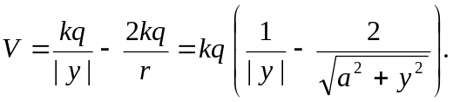
b) 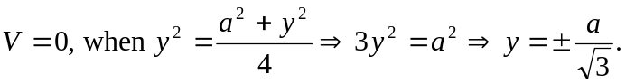
c)
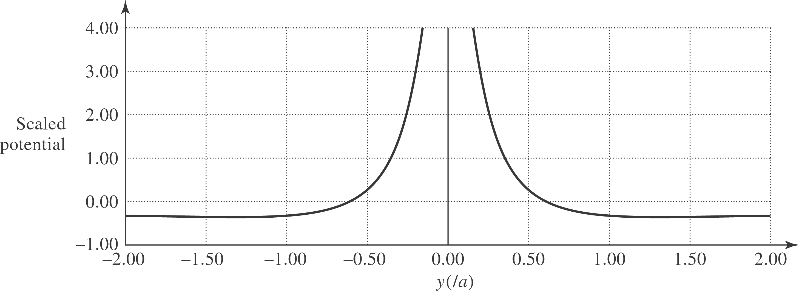

d) 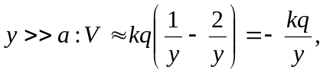which is the potential of a point charge 

